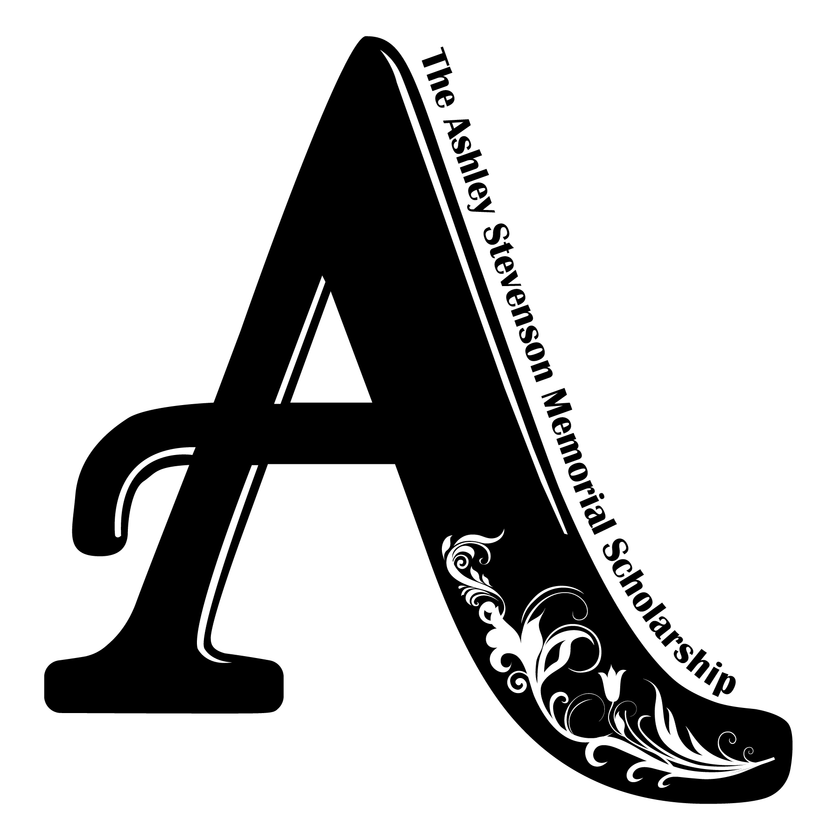
Ashley Stevenson Memorial Scholarship
Sponsorship Levels and Benefits

$5000 FOUNDING SPONSOR
5K Benefits:
  - Prominent website acknowledgement as Founding Sponsor
  - Included in at least 10 social media posts/mentions
  - Acknowledgement as Founding Sponsor on all print material, to include, but not limited to: Save the Date, Invitation, Event promotional material, Posters
  - 3 banners on course (4ft x 6ft max size)
  - Logo recognition of Founding Sponsor on T-shirt (4/color)
  - Prominent branded opportunity on stage, i.e., podium
  - Speaking opportunity at event
  - 4 entries to race
  - * In the event pro-bono media is provided to foundation: Founding Sponsor will be recognized accordingly
Banquet Benefits:
  - Prominent website acknowledgement as Founding Sponsor
  - Included in at least 5 social media posts/mentions
  - Acknowledgement as Founding Sponsor on all print material, to include, but not limited to: Save the Date, Invitation, Event promotional material, Posters
  - Full-page ad in program
  - Prominent branded opportunity on stage area
  - Speaking opportunity at event
  - 5 tickets to event with VIP seating

$1000 GOLD SPONSOR
5K Benefits:
  - Prominent website acknowledgement
  - Included in at least 8 social media posts/mentions
  - Acknowledgement as Gold Sponsor on all print material, to include, but not limited to: Save the Date, Invitation, Event promotional material, Posters
  - 2 banners on course (2ft x 4ft max size)
  - Logo recognition of Gold Sponsor on T-shirt (4/color)
  - Prominent branded opportunity on stage, i.e., podium
  - Speaking opportunity at event
  - 4 entries to race
  - * In the event pro-bono media is provided to foundation: Gold Sponsor will be recognized accordingly
Banquet Benefits:
  - Prominent website acknowledgement as Gold Sponsor
  - Included in at least 3 social media posts/mentions
  - Acknowledgement as Gold Sponsor on all print material, to include, but not limited to: Save the Date, Invitation, Event promotional material, Posters
  - 1/2-page ad in program
  - 5 tickets to event with VIP seating

$500 SILVER SPONSOR
5K Benefits:
  - Website acknowledgement as Silver Sponsor
  - Included in at least 4 social media posts/mentions
  - Name recognition as Silver Sponsor on all print material, to include, but not limited to: Save the Date, Invitation, Event promotional material, Posters
  - 1 banner on course (2ft x 4ft max size)
  - Acknowledgement of Silver Sponsor on T-shirt (b/w)
  - Prominent branded opportunity on stage, i.e., podium
  - Speaking opportunity at event
  - 2 entries to race
Banquet Benefits:
  - Website acknowledgement as Silver Sponsor
  - Included in at least 3 social media posts/mentions
  - Name recognition as Silver Sponsor on all print material, to include, but not limited to: Save the Date, Invitation, Event promotional material, Posters
  - Name in program
  - 2 tickets to event

$250 BRONZE SPONSOR
5K Benefits:
  - Website acknowledgement as Bronze Sponsor
  - Included in at least 4 social media posts/mentions
  - Name recognition as Bronze Sponsor on all print material, to include, but not limited to: Save the Date, Invitation, Event promotional material, Posters
  - 1 banner on course (2ft x 4ft max size)
  - Acknowledgement of Silver Sponsor on T-shirt (b/w)
  - Prominent branded opportunity on stage, i.e., podium
  - 2 entries to race
Banquet Benefits:
  - Prominent website acknowledgement as Bronze Sponsor
  - Included in at least 3 social media posts/mentions
  - Name recognition as Bronze Sponsor on all print material, to include, but not limited to: Save the Date, Invitation, Event promotional material, Posters
  - Name in program
  - 2 tickets to event

Targeted Marketing Opportunities

$350 5K Water Stop – 3 available
Benefits:
  - Website acknowledgement as Water Stop Sponsor
  - Included in at least 2 social media posts/mentions
  - Name recognition as Water Stop Sponsor on all print material, to include, but not limited to: Save the Date, Invitation, Event promotional material, Posters
  - 1 banner on course (4ft x 6ft max size)
  - Recognition & Decorating opportunities at Water Stop
  - Employee volunteer opportunity to man Water Stop
  - Acknowledgement of Water Stop Sponsor on T-shirt (b/w)
  - 2 entries to race

$250 5K Registration Table – 2 available
Benefits:
  - Website acknowledgement as Registration Sponsor
  - Included in at least 2 social media posts/mentions
  - Name recognition as Registration Sponsor on all print material, to include, but not limited to: Save the Date, Invitation, Event promotional material, Posters
  - 1 banner on course (4ft x 6ft max size)
  - Recognition & Decorating opportunities at Registration Table
  - Employee volunteer opportunity to man Registration
  - Acknowledgement of Registration Sponsor on T-shirt (b/w)
  - 2 entries to race

